BIP

Reports and Analytics -> Tools -> Browse catalog -> Data Model

In Data model we have Properties like:
- Data Sets
- Event Triggers
- Flexfields
- List of Values
- Parameters
- Bursting

In Data sets -> Select SQL Query -> Name, Data Source, Type of SQL

Write a Query in Data Model and then load any Template.
We can Load basic templates or any RTF, PDF, Excel, Flash, XSL Stylesheet or eText Template.

Scheduling Report:
Tools -> Schedule a Report
Search Name - > + -> Name, Layout, Format(Email, Printer, Fax, Content Server)

Deploying Report in Development(Just another way of Deploying)
Setup & Maintenance -> Manage Enterprise Scheduler Job Definitions and Job sets for HCM and Related Applications (ESS Job)

In Path till /Custom/ will be There
Path - /Custom/Sashank/
Job Application Name- FscmEss
JobType- BIP JobType
Report ID is Whole Path in Properties and add .xdo if not there(Go into File History for path)
Add Parameters if any available in Data model

Sashank4 is the Scheduled Process Name.

Note: We can Schedule only Reports as far as I know
In here only there will be option to create list of values sources and Choose LovType as Userdefined and Give the SQL Query

Application Name- Application Common Resources
List of Values- Sashank4_LV

In Bursting we need 1 ‘KEY’ always for Split by and Deliver by and Enable Bursting in Properties

Bursting is used to Deliver the Report through Email, FTP or any other Delivery Method.
The Output name as to be same as bursting LAYOUT name. In View list and properties Make PDF as Default, and enable bursting in report.

If we are trying to use Bursting then specify Bursting in ESS Job Scheduler

select distinct
SEGMENT1 as "KEY",
'Sashank Basic Schedule' TEMPLATE,
'PDF' OUTPUT_FORMAT,
'PO_DATA_OUTPUT' OUTPUT_NAME,
'EMAIL' DEL_CHANNEL,
'sai-sashank.puli@capgemini.com' PARAMETER1,
'accounts.receivable@example.com' PARAMETER2,
'noreply@oracle.com' PARAMETER3,
'Demo Bursting' PARAMETER4,
'Hi'||chr(13)|| 'Please find attached PO Data' PARAMETER5,
'true' PARAMETER6
from PO_HEADERS_ALL
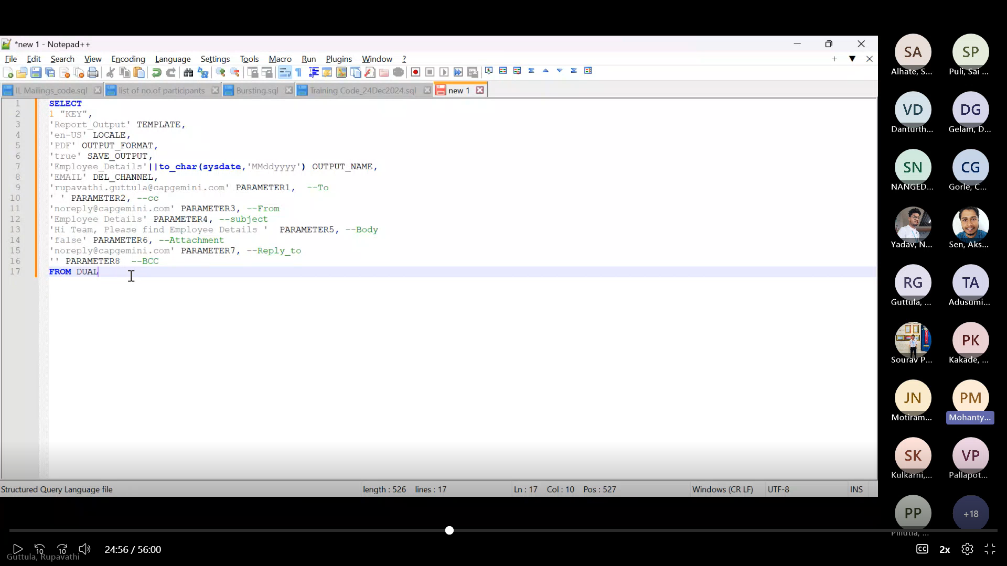
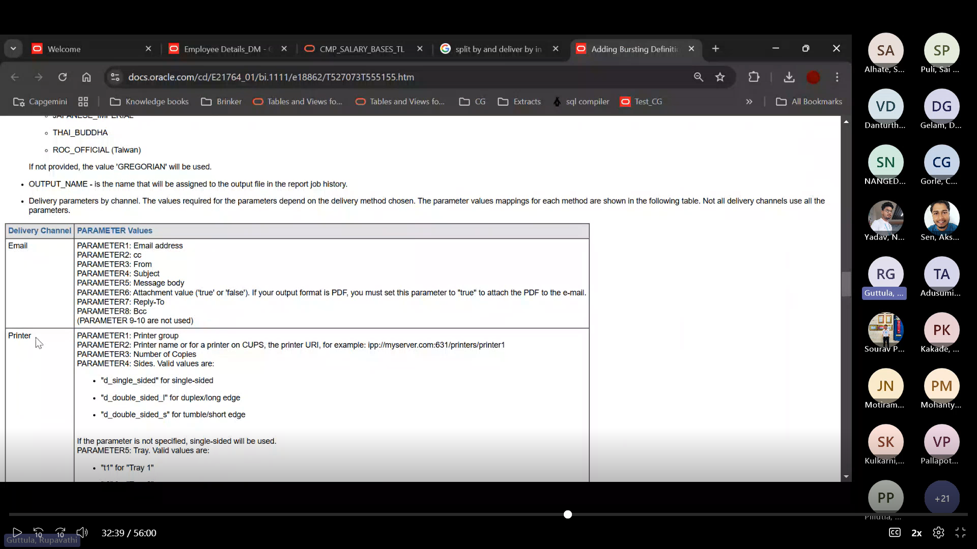

Output Formats:
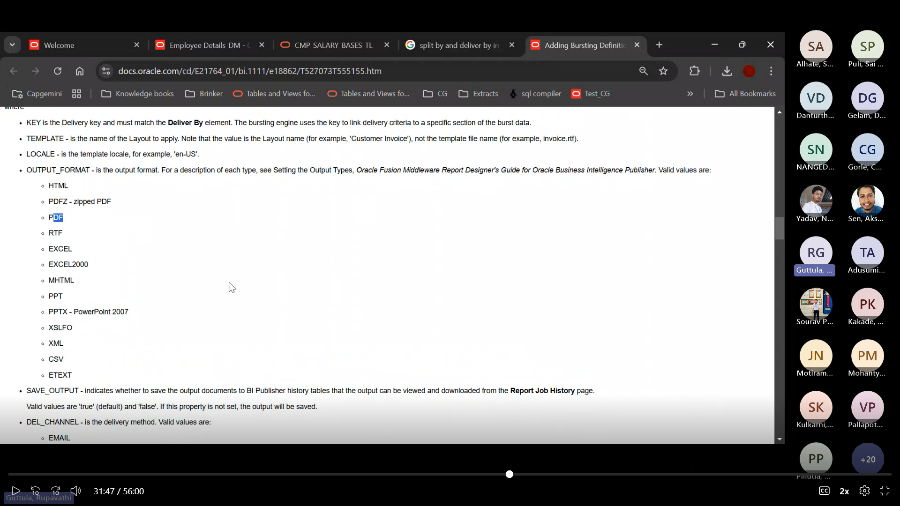

Delivery Channels:
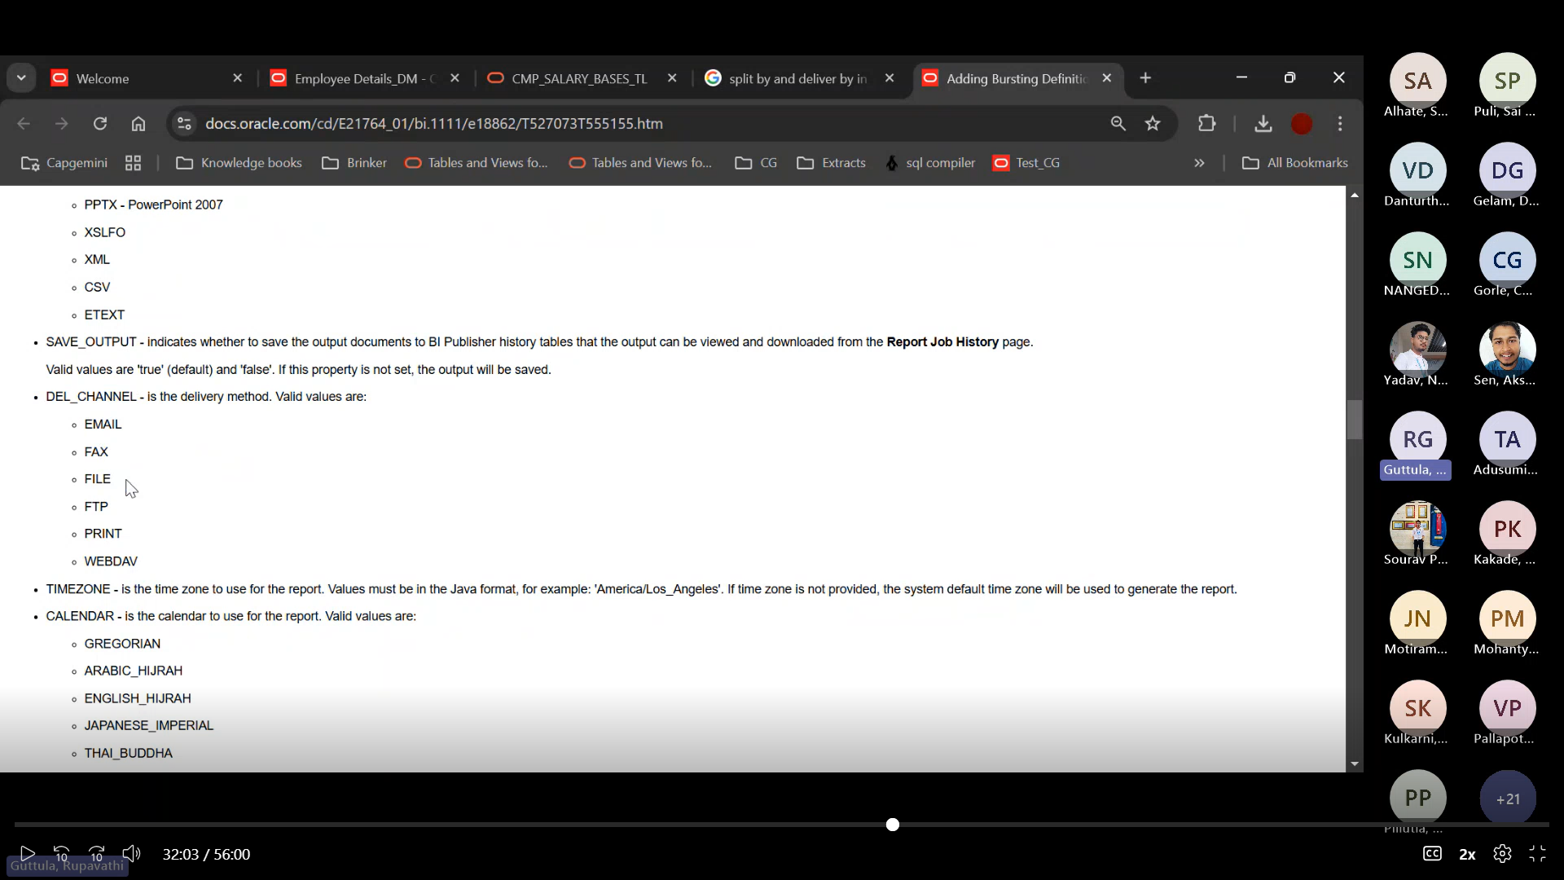

2 Types of eText Templates:
- Delimeter Based Templates
- Position Based Templates(It has sequence and Padding)

Creating a WORD RTF Template:

- Create a Data Model
- And Save as Sampled Data then Export the Data into our System
- If we have BIP installed in our PC then select it and select Sample XML and Load.
- Load Data model and RTF Template
- If we have parameters Uncheck the Auto-Run option in Properties

Code:
- We need to Type for-each to iterate and end for-each to stop iterating

- <?sort: INVOICE_NUM; ‘descending’ ?><?INVOICE_NUM?>

- To Break page after 10 records- <?if:position() mod 10=0 ?> <xsl:attribute name=”break-before”>page</xsl:attribute><?end if?>

- Timestamp - <?xdoxslt:sysdate (‘DD MON YYYY HH24:MI’)?> or Insert -> Date & Time

- After every Grouping - <?split-by-page-break:?> put it infront of G1

- Decode - <?xdofx:decode(PO_STATUS,’OPEN’,Open PO’,’CLOSED’,’Closed PO’,’Others’)?>

- <?choose:?>
<?when:count(INVOICE_NUM) > 0 ?>
<?end when?>
<?otherwise: ?>
No DATA FOUND
<?end otherwise?>
<?end choose?>

If We want to work with data then after loading the data and selecting load sample data, click on table wizard to select the data and select the info like G1 or G2, group by, asc or desc and more.

Letter:

We have Form Fields with XML Tag names.
Add Type, Default Text(Mostly for Date), Bookmark*, and in Add Help Text add XML Tag Name.

Save the File in .RTF extension

After uploading Layout Don’t Forget to Uncheck Auto-Run(Always we need to Refresh the page), in caching user level & document caching in properties(Otherwise until 30 mins the cache will be there in the system and the data won’t appear).

We need to Click on Edit in report to Download the Sample Form Fields Template.

Trunc will be used to eliminate Timestamp. Trunc (SYSDATE) BETWEEN TRUNC(TN.Effective_Start_Date) AND TRUNC(TN.Effective_End_Date)

EXCEL:

Save the File in .xls Extension

While Uploading in Instance choose Template type as Excel Template

We can’t use the same tag names when two or more tables joined so Change the Tag name of the other tables like removing first _ from PO_HEADER_ID.
Then in G1 we have settings and in that we can click on create link to Join tables with same attributes(Even after changing the Tag name we can use it for joining)

If we are Doing Drill down then only for Second Table we need to use Grouping Element as G2 but G1 we need to select all the tables the Use Grouping Element. (Note: Select an Extra Line below the rows, it will gives you a look between two outputs)

Multi Sheet – It will Give the Grouping Outputs in Multiple Sheets.
Drill Down – It will Give the Grouping Outputs in the Same Sheet with space below every Grouping.

All Tag names should be in Capital
Excel Template Tags:
• Element Syntax - XDO_?element_name? (It is Column Name)
Formula -> Name Manager -> New -> Give name, sheet number

• Group Syntax – XDO_GROUP_?G_1? (XDO_GROUP_?Group_name?)
Select all the Element Columns(Data not the Headings) Then Name the Formula

• Name Sheet Name as – XDO_METADATA
Version
ARU-dbdrv
Extractor Version
Template Code
Template Type TYPE_EXCEL_TEMPLATE
Preprocess XSLT File
Last Modified Date
Last Modified By

Data Constraints:

For Multi-Sheet Template:
Version
ARU-dbdrv
Extractor Version
Template Code
Template Type TYPE_EXCEL_TEMPLATE
Preprocess XSLT File
Last Modified Date
Last Modified By

Data Constraints:
XDO_SHEET_? <.//G_1?>
XDO_SHEET_NAME_? <?concat('PONumber-'.//PO_HEADER_ID)?>

For modifying Standard Oracle Docs(Reports) we need to use Fusion URL till oraclepdemos.com/ then add xmlpserver

